A
Project Report on
FairCred - Credit Engine using Explainable AI

Submitted for partial fulfilment of the requirements for the award of the degree
of

BACHELOR OF ENGINEERING

In

COMPUTER SCIENCE AND ENGINEERING

By

Mamidi Vaibhav Sai Manish (2451-22-733-127)
J Bhanu (2451-22-733-309)
K Malvik Reddy (2451-22-733-095)

Under the guidance of

G. Madhu
Assistant Professor Department of CSE



MATURI VENKATA SUBBA RAO (MVSR) ENGINEERING COLLEGE

(An Autonomous Engineering College)
Department of Computer Science and Engineering (Affiliated to Osmania University & Recognized by AICTE) Nadergul, Saroor Nagar Mandal, Hyderabad – 501 510 Academic Year: 2025-26

MATURI VENKATA SUBBA RAO (MVSR) ENGINEERING COLLEGE

(An Autonomous Engineering College)
Department of Computer Science and Engineering (Affiliated to Osmania University & Recognized by AICTE) Nadergul, Saroor Nagar Mandal, Hyderabad – 501 510 Academic Year: 2025-26


Certificate
This is to certify that the project work entitled by “FairCred- Credit Engine using Explainable AI” is a bonafide work carried out by Mr. Mamidi Vaibhav Sai Manish (2451-22-733-127), Mr. J Bhanu (2451-22-733-309) , Mr. K Malvik Reddy (2451-22-733-095) in partial fulfilment of the requirements for the award of degree of Bachelor of Engineering in Computer Science and Engineering from Maturi Venkata Subba Rao (MVSR) Engineering College, affiliated to OSMANIA UNIVERSITY, Hyderabad, during the Academic Year 2025-26 under our guidance and supervision.

The results embodied in this report have not been submitted to any other university or institute for the award of any degree or diploma to the best of our knowledge and belief..

Internal Guide Head of the Department
G. Madhu Dr. Akhil Khare
Assistant Professor Professor
Department of CSE Department of CSE
MVSREC. MVSREC.

External Examiner

i

DECLARATION

This is to certify that the work reported in the present project entitled “FairCred - Credit Engine using Explainable AI” is a record of bonafide work done by us in the Department of Computer Science and Engineering, Maturi Venkata Subba Rao (MVSR) Engineering College, Osmania University during the Academic Year 2025-26. The reports are based on the project work done entirely by us and not copied from any other source. The results embodied in this project report have not been submitted to any other University or Institute for the award of any degree or diploma.

Mr. Mamidi Vaibhav Sai Manish | Mr. J Bhanu | Mr. K Malvik Reddy
2451-22-733-127 | 2451-22-733-309 | 2451-22-733-095

ACKNOWLEDGEMENT

We would like to express our sincere gratitude and indebtedness to our project guide
G. Madhu, Assistant Professor for his valuable suggestions and interest throughout the course of this project.

We are also thankful to our principal Dr. Marathi Kameswara Rao and Dr. Akhil Khare, Professor and Head, Department of Computer Science and Engineering, Maturi Venkata Subba Rao Engineering College, Hyderabad for providing excellent infrastructure for completing this project successfully as a part of our B.E. Degree (CSE). We would like to thank our project coordinator for her constant monitoring, guidance and support.

We convey our heartfelt thanks to the lab staff for allowing us to use the required equipment whenever needed. We sincerely acknowledge and thank all those who gave directly or indirectly their support in the completion of this work.

Mr. Mamidi Vaibhav Sai Manish (2451-22-733-127)
Mr. J Bhanu (2451-22-733-309)
Mr. K Malvik Reddy (2451-22-733-095)

VISION
- To impart technical education of the highest standards, producing competent and confident engineers with an ability to use computer science knowledge to solve societal problems.

MISSION
- To make learning process exciting, stimulating and interesting.
- To impart adequate fundamental knowledge and soft skills to students.
- To expose students to advanced computer technologies in order to excel in engineering practices by bringing out the creativity in students.
- To develop economically feasible and socially acceptable software.

PEOs:
PEO-1: Demonstrate technical competence to successfully execute industry related software projects as a team member, leader or entrepreneur to meet customer business objectives.
PEO-2: Engage in life-long learning process by pursuing professional certifications, higher education or research in the emerging areas of information processing and intelligent systems at a global level.
PEO-3: Advance in their professional careers by understanding the impact of computing on society or environment to make technical contributions using a multidisciplinary and ethical approach.

PROGRAM OUTCOMES(POs)
At the end of the program the students (Engineering Graduates) will be able to:
- Engineering knowledge: Apply the knowledge of mathematics, science, engineering fundamentals, and an engineering specialization to the solution of complex engineering problems.
- Problem analysis: Identify, formulate, review research literature, and analyse complex engineering problems reaching substantiated conclusions using first principles of mathematics, natural sciences, and engineering sciences.
- Design/development of solutions: Design solutions for complex engineering problems and design system components or processes that meet the specified needs with appropriate consideration for the public health and safety, and the cultural, societal, and environmental considerations.

- Conduct investigations of complex problems: Use research-based knowledge and research methods including design of experiments, analysis and interpretation of data, and synthesis of the information to provide valid conclusions.
- Modern tool usage: Create, select, and apply appropriate techniques, resources, and modern engineering and IT tools including prediction and modelling to complex engineering activities with an understanding of the limitations.
- The engineer and society: Apply reasoning informed by the contextual knowledge to assess societal, health, safety, legal and cultural issues and the consequent responsibilities relevant to the professional engineering practice.
- Environment and sustainability: Understand the impact of the professional engineering solutions in societal and environmental contexts, and demonstrate the knowledge of, and need for sustainable development.
- Ethics: Apply ethical principles and commit to professional ethics and responsibilities and norms of the engineering practice.
- Individual and team work: Function effectively as an individual, and as a member or leader in diverse teams, and in multidisciplinary settings.
- Communication: Communicate effectively on complex engineering activities with the engineering community and with society at large, such as, being able to comprehend and write effective reports and design documentation, make effective presentations, and give and receive clear instructions.
- Project management and finance: Demonstrate knowledge and understanding of the engineering and management principle and apply these to one’s own work, as a member and leader in a team, to manage projects and in multidisciplinary environments.
- Lifelong learning: Recognize the need for and have the preparation and ability to engage in independent and life-long learning in the broadest context of technological change.

PROGRAM SPECIFIC OUTCOMES (PSOs)

- (PSO-1) Demonstrate competence to build effective solutions for computational real-world problems using software and hardware across multi-disciplinary domains.
- (PSO-2) Adapt to current computing trends for meeting the industrial and societal needs through a holistic professional development leading to pioneering careers or entrepreneurship

COURSE OBJECTIVES AND OUTCOMES

Course Objectives:
  - Understand the significance of survey in necessary domains for problem identification.
  - Understand to map requirements into software specification.
  - Learn to apply concepts of software engineering for design of the identified real-world problem
  - Improve the coding capabilities by implementing the various modules of project
  - Comprehend the suitable documentation procedure for a technical project.
  - Exhibit effective communication and presentation skills.
  - Learn the process of planning the complete lifecycle of a project

Course Outcomes:
CO1: Review recent advancements to formulate a precise problem statement with applications towards society.
CO2: Identify system requirements, explore design alternatives to design software-based solution within the scope of project.
CO3: Implement, test, and build the solution using contemporary technologies and tools.
CO4: Exhibit effective communication to present ideas clearly and produce well-structured technical report.
CO5: Demonstrate qualities necessary to work in a team and execute project as per plan.

ABSTRACT

Credit access remains a critical challenge for the underbanked population in developing economies, where traditional credit scoring models rely heavily on formal financial histories such as CIBIL scores in India. These conventional systems exclude millions of underbanked and unbanked individuals, including gig workers, informal laborers, freelancers, and small business owners who lack structured credit records. As a result, a large segment of the population remains outside formal lending, limiting financial inclusion and economic mobility.​

FairCred is an AI-driven credit scoring engine designed to bridge this gap by leveraging behavioral, digital, socio-economic, and contextual data to predict default probability without relying on traditional credit files. The system integrates machine learning algorithms with SHAP-based explainability to ensure transparency, fairness, and regulatory compliance, while addressing key market challenges such as data quality, feature interdependencies, bias mitigation, and GDPR-like regulatory alignment. To achieve this, the project constructs a synthetic dataset reflecting realistic underbanked population characteristics, implements gradient boosting and neural network models, and provides a privacy-preserving framework using token-based verification and differential privacy techniques.​

Key outcomes include a hybrid ML-based scoring engine targeting 92%+ accuracy, SHAP-powered explainability dashboards, fairness audit mechanisms, fintech-ready API endpoints, and deployment-ready documentation. This enables digital lending platforms, NBFCs, and embedded finance providers to safely extend credit to underbanked segments, with experimental results indicating over 15% improvement in default detection and around 25% reduction in fairness violations compared to traditional models.

Mr. Mamidi Vaibhav Sai Manish (2451-22-733-127)
Mr. J Bhanu (2451-22-733-309)
Mr. K Malvik Reddy (2451-22-733-095)

TABLE OF CONTENTS

CONTENTS PAGE NO.s
Certificate | i
Declaration | ii
Acknowledgement | iii
Vision and Mission, PEOs, POs and PSOs | iv
Course Objectives and Outcomes | v
Abstract | vii
Table of Contents | viii
List of Figures | ix
List of Tables | x
Contents
1. INTRODUCTION | 01 - 05
1.1 Problem Statement | 02
1.2 Objective | 02
1.3 Motivation | 03
1.4 Scope | 03
1.5 Software and Hardware Requirements | 04 - 05
2. LITERATURE SURVEY | 06 - 09
2.1 Survey of Credit Scoring and Risk Prediction Methods | 06
2.2 Techniques and Algorithms Relevant to the Project | 07
2.3 Applications | 08 - 09
3. SYSTEM DESIGN | 10 - 14
3.1 System Architecture and Workflow of the System | 10
3.2 Each Module Description | 11
3.3 Project Plan (Development Timeline) | 12 - 13
REFERENCES | 14

LIST OF FIGURES
Figure No Figure Name Page No

Fig. 3.1(a) | System Architecture of FairCred Credit Scoring Engine | 10
Fig. 3.1(b) | Workflow of the Proposed FairCred System | 10

LIST OF TABLES
Table No Table Name Page No

Table 1.5 | Software and Hardware Requirements | 04 - 05
Table 3.1 | Module-wise Description of the Proposed System | 10 - 11
Table 3.3 | Project Plan (Development Timeline) | 12 - 13

x

INTRODUCTION
Credit access is a fundamental component of economic development and financial inclusion. Financial institutions rely on credit evaluation mechanisms to assess a borrower’s repayment capacity and associated risk before approving loans. Traditionally, this evaluation has been carried out using structured financial information such as credit bureau scores, repayment history, and formal banking records. While effective for individuals with established credit profiles, this approach excludes a large segment of the population who lack formal financial documentation.
In developing economies, a significant number of individuals operate in informal sectors, depend on irregular income sources, or are first-time borrowers. These groups often remain underbanked or unbanked despite being financially capable. The rapid growth of digital platforms, mobile usage, and online transactions has resulted in the generation of alternative data that reflects behavioral and socio-economic patterns. When analyzed appropriately, such data can provide valuable insights into an individual’s creditworthiness.
Recent advancements in machine learning have enabled the processing of complex and heterogeneous datasets for predictive modeling. However, many credit scoring models function as black-box systems, offering high accuracy but limited interpretability. This lack of transparency raises concerns related to trust, bias, and regulatory compliance. To address these challenges, there is a growing demand for explainable and ethical artificial intelligence systems in financial decision-making.
FairCred is proposed as a credit engine that integrates machine learning with Explainable AI techniques to predict the probability of default using alternate data sources. The system emphasizes transparency, fairness, and usability, enabling lenders to make informed decisions while ensuring accountability in automated credit assessment.

Problem Statement
A large portion of the population is excluded from formal credit systems due to the absence of conventional credit history. Existing credit evaluation frameworks depend heavily on credit bureau scores and banking data, which are unavailable for individuals from informal employment backgrounds, rural regions, or first-time borrowers. As a result, financially capable individuals are often denied access to loans, limiting economic mobility and financial inclusion.
Furthermore, modern machine learning-based credit scoring systems frequently lack explainability. Borrowers are unable to understand why a loan application is rejected, and lenders face difficulties in justifying decisions to regulatory authorities. This opacity introduces risks related to bias, discrimination, and ethical concerns. There is therefore a need for a transparent, explainable, and scalable credit scoring framework that can assess risk using alternate data while maintaining fairness and interpretability.

1.2 Objectives

The primary objectives of the FairCred project are as follows:

- Alternative Credit Signal Construction:
To develop a production-ready credit scoring system that predicts a borrower’s probability of default without relying on traditional credit bureau data, instead targeting underbanked and thin-file customers who are typically excluded from conventional scoring models.
​
- Unified Multi-Source Feature Framework:
To systematically integrate behavioral, digital, and socio-economic indicators such as transaction patterns, device usage, and income stability into a unified feature pipeline that captures holistic creditworthiness beyond formal credit histories.​

- Robust Machine Learning Risk Estimation:
To apply and benchmark advanced machine learning techniques, including ensemble tree models and neural networks, in order to achieve accurate, stable, and generalizable credit risk estimates suitable for real-world lending environments.

- Ethical, Fair, and Privacy-Preserving Design:
To design a credit decisioning system that embeds fairness constraints, bias monitoring, and privacy-by-design mechanisms (including data minimization, anonymization, and consent-based signals), thereby supporting ethical lending practices and alignment with GDPR-like regulatory standards.

Motivation
Financial inclusion remains a critical challenge despite technological advancements in the banking and financial sectors. Many individuals are excluded from credit opportunities not due to financial irresponsibility, but due to insufficient documentation or lack of historical data. The increasing availability of alternative digital data presents an opportunity to address this gap by enabling more inclusive credit evaluation.
At the same time, regulatory bodies and financial institutions are emphasizing the importance of transparency and accountability in automated decision systems. Explainable AI provides mechanisms to interpret model behavior and understand the factors influencing predictions. The motivation behind FairCred is to combine predictive performance with interpretability, thereby building trust among lenders and borrowers while supporting responsible and ethical use of artificial intelligence in finance.

1.3 Scope

Inclusions
- Use of synthetic datasets representing underbanked and unbanked populations
- Integration of behavioral, digital, and socio-economic features
- Machine learning-based probability of default prediction
- Explainability using SHAP-based feature attribution
- Dashboard-based visualization for credit insights
Exclusions
- Usage of real banking or credit bureau data
- Real-time production deployment
- Direct integration with banking or loan disbursement systems

Software & Hardware Requirements
Software Requirements

Category | Tools / Libraries | Version | Purpose
Core | Python | 3.8+ | Primary programming language for model development and system implementation
Data Processing | Pandas, NumPy | 2.0.3, 1.24.3 | Data cleaning, preprocessing, feature engineering, and handling structured datasets
Machine Learning | Scikit-learn | 1.3.0 | Model training, scaling, performance evaluation, and train-test split
Explainable AI | SHAP | 0.43+ | Model explainability and feature importance analysis
Visualization | Matplotlib, Seaborn, Plotly | 3.7.2, 0.12.2, 5.16.1 | Exploratory data analysis and interactive visualizations
Web Framework | Streamlit | 1.28.1 | Development of interactive dashboards for credit scoring insights
Dashboard Utilities | Streamlit Components | Latest | User interaction, filtering, and result presentation
Development Environment | Jupyter Notebook, VS Code | Latest | Model experimentation and code development

Hardware Requirements:
- Processor: Intel i5 or equivalent
- RAM: Minimum 8 GB
- Storage: 256 GB SSD
- Optional GPU for faster model training

2. BACKGROUND / LITERATURE SURVEY

2.1 Survey of Credit Scoring and Risk Prediction Methods

Credit scoring has historically been dominated by statistical models such as logistic regression and linear discriminant analysis, which became standard tools for estimating default risk in retail lending from the 1970s onward. These traditional scorecards rely mainly on structured financial attributes like income, repayment history, and existing credit lines, and work well for borrowers with rich bureau records but systematically exclude underbanked and thin-file customers who lack formal credit footprints.​

To improve discrimination power and capture nonlinear relationships, financial institutions gradually adopted tree-based methods and ensemble models, including Decision Trees, Random Forests, and Gradient Boosting Machines. These approaches provide higher predictive accuracy than classical scorecards, yet they were often deployed as opaque “black boxes,” raising concerns about interpretability, regulatory acceptance, and hidden biases, especially when used to automate high-stakes lending decisions.​

From the mid-2010s, research on alternative and behavioral data such as mobile usage, digital footprints, and transactional patterns showed that these signals can substantially improve risk prediction for unbanked and underbanked segments when combined with appropriate modeling techniques. Recent work emphasizes that the next generation of credit scoring must jointly address performance, fairness, and privacy, leading to architectures that integrate powerful ML models with Explainable AI (XAI) and fairness-aware learning for responsible deployment in digital lending ecosystems.
Credit Scoring Evolution Timeline (Summary)
- 1970s–2000s: Logistic regression and scorecards dominate consumer credit risk modeling using bureau and financial statement data.​
- 2005–2015: Machine learning models (Random Forests, Gradient Boosting, SVM) improve nonlinear risk discrimination but remain largely non-transparent.​
- 2016–2020: XGBoost, LightGBM, and deep networks become popular in credit risk, achieving accuracy gains of 5–10% over classical models.​
- 2021–2025: Alternative-data and XAI-based credit scoring emerges, targeting financial inclusion, fairness, and regulatory-grade transparency.

2.2 Techniques and Algorithms Relevant to the Project

- Gradient Boosting and Tree Ensembles
Gradient Boosting Machines, including XGBoost and LightGBM, iteratively train decision trees so that each new tree focuses on correcting the residual errors of the previous ensemble, yielding highly accurate nonlinear decision boundaries for default prediction. These models handle heterogeneous feature types, missing values, and complex interactions, while also exposing feature importance rankings that help practitioners understand which variables most influence risk classification. However, raw gradient-boosted models still behave as complex ensembles, and their decision logic is not immediately interpretable at the individual borrower level without additional XAI tools.​
- Neural Networks for Behavioral and Alternative Data
Feed-forward and deep neural networks, including architectures inspired by recurrent and attention-based models, have been applied to behavioral and transaction-stream data to capture subtle patterns that are difficult for linear or shallow models to learn. These networks excel at modeling high-dimensional feature spaces that arise from mobile usage, app interaction logs, and fine-grained transaction histories, which are especially valuable for underbanked customers whose creditworthiness is encoded more in behavior than in formal records. Their main drawbacks are interpretability and overfitting risk, motivating the use of regularization, careful validation, and post-hoc explainability methods before adoption in regulated credit workflows.​
- Explainable AI (SHAP, LIME) and Fairness-Aware Modeling
Explainable AI methods such as SHAP and LIME approximate the contribution of each feature to an individual model prediction, enabling stakeholders to see why a given borrower was classified as high or low risk. These techniques are now widely studied in credit risk contexts to satisfy regulatory expectations for transparency and to support applicant-facing explanations, especially when ensemble or neural models are used instead of simple scorecards. In parallel, fairness-aware learning frameworks incorporate metrics such as disparate impact, equalized odds, and demographic parity into model evaluation and optimization, aiming to reduce discriminatory patterns against protected groups while maintaining acceptable predictive performance.​

2.3 Applications

1. Inclusive Digital Lending and Embedded Finance

AI-based, explainable credit scoring enables digital lenders and embedded finance providers to underwrite first-time and underbanked borrowers by leveraging alternative data such as mobile usage, app behavior, and digital payments. This supports instant or near real-time loan decisions within e-commerce, payments, and mobility platforms, expanding credit access and improving customer experience while maintaining risk controls through continuous model monitoring and explanation-driven review.​

2. Microfinance, MSME, and Gig-Worker Underwriting

For microfinance institutions and MSME-focused lenders, alternative-data credit scoring helps evaluate small merchants, gig workers, and informal-sector entrepreneurs who traditionally lack collateral or bureau history. By combining behavioral signals with explainable ML models, lenders can segment risk more precisely, reduce manual underwriting effort, and design tailored products such as dynamic credit lines or short-tenure working-capital loans, thereby improving portfolio quality and financial inclusion outcomes.​

3. Risk Governance, Regulation, and Policy Support

Regulators, development agencies, and large financial institutions use explainable and fairness-audited credit risk models to assess systemic risk, monitor potential discrimination, and design responsible-lending guidelines. Aggregated outputs from these models can inform stress tests, targeted credit support programs, and financial inclusion policies, while XAI reports and fairness metrics provide traceable evidence that AI-driven decision engines meet transparency and ethical standards expected in modern credit markets.

4. Dynamic Credit Line Management and Portfolio Optimization

AI-driven, explainable credit scoring enables lenders to move from static limits to dynamic credit line management, where exposure is adjusted based on real-time behavioral and transactional signals. Portfolio managers can use these models to re-segment customers,

proactively reduce limits for emerging high-risk profiles, and offer higher limits or better terms to low-risk, underutilized segments, improving both risk-adjusted return and customer satisfaction.​

5. Fraud Detection and Anomaly Monitoring

Credit scoring models augmented with behavioral and device-level data can be repurposed for fraud detection, identifying anomalous application patterns, device inconsistencies, or synthetic identities that deviate from learned risk profiles. Such systems operate in real time, flagging suspicious cases for manual review, reducing approval of fraudulent accounts, and protecting both lenders and genuine borrowers from identity theft and application fraud.

6. Rental Housing, Utilities, and Subscription Credit Assessment

Landlords, utility providers, telecoms, and subscription services increasingly rely on AI-based credit scoring to evaluate prospective tenants or subscribers using alternative data, such as utility payment history, rent records, and digital footprints. This allows service providers to accept reliable but thin-file customers who lack formal credit history, while still controlling default risk and designing flexible deposit or prepaid/postpaid schemes aligned with individual risk levels.

3. SYSTEM DESIGN

3.1 System Architecture / Workflow of the system
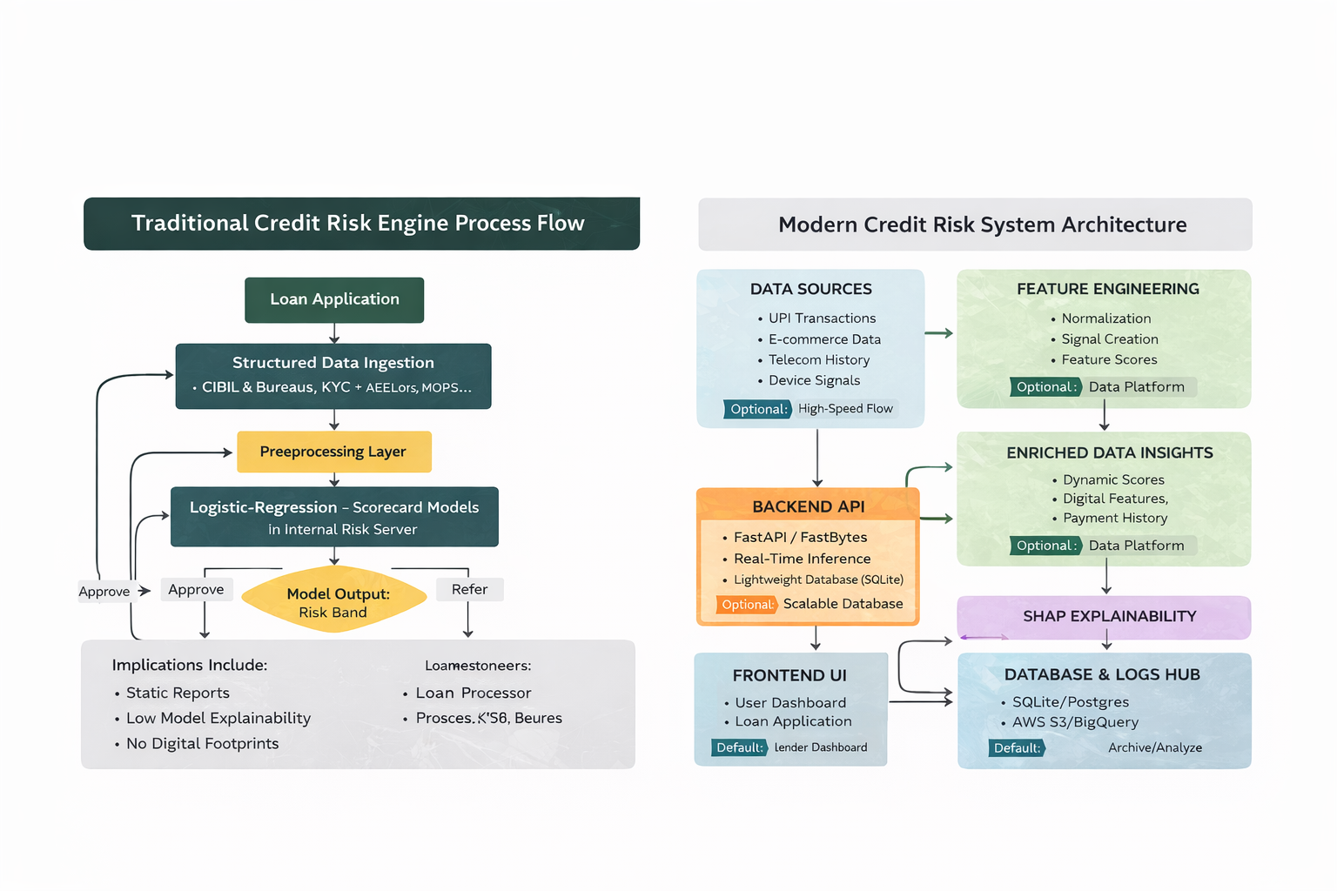

Fig 3.1(a)System Architecture of Proposed Solution

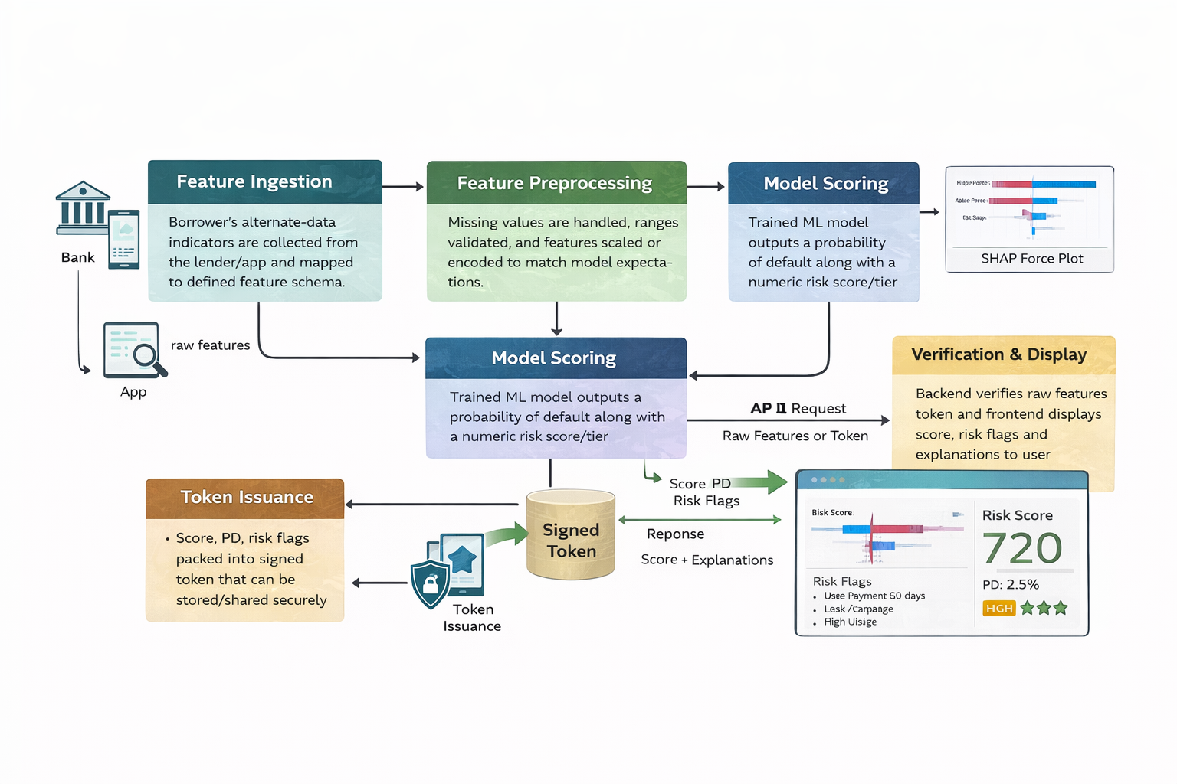

Fig 3.1(b)Workflow of the system

3.2 Each Module Description

Module Name | Input | Processing | Output | Tools/ Technologies
Data Ingestion & Preprocessing | Raw borrower dataset | Data cleaning, missing value handling, encoding, scaling, data split | Cleaned training and testing datasets | Pandas, NumPy, Scikit-learn
Feature Engineering & Selection | Preprocessed data | Feature construction, correlation analysis, feature selection | Optimized feature set | Scikit-learn
ML Model Training | Engineered features | Model training and validation | Trained credit risk model | Scikit-learn
Neural Network Modeling | Normalized feature data | Neural network training | Default probability predictions | TensorFlow, Keras
Ensemble & Calibration | Model predictions | Model combination and probability calibration | Final risk score | Scikit-learn
Explainability | Trained model and features | Feature importance and local explanations | Explainable model outputs | SHAP
Fairness Analysis | Predictions and sensitive features | Bias detection and fairness evaluation | Fairness metrics and reports | Fairlearn
API Service Layer | Borrower feature input | Prediction and explanation serving | Credit decision response | Flask / FastAPI
Dashboard & Monitoring | Model outputs and metrics | Visualization and monitoring | Interactive dashboard | Streamlit, Plotly

3.3 Project Plan (Development Timeline)

Phase | Duration | Milestones | Dependencies
1. Requirement Analysis | 1 week | Problem definition, identification of alternate data sources | Stakeholder discussions
2. Data Collection & Preparation | 2 weeks | Synthetic dataset creation, data cleaning, exploratory analysis | Dataset design approval
3. Feature Engineering | 2 weeks | Feature construction, selection, and preprocessing | Cleaned dataset
4. Model Development | 3 weeks | Trained ML models, initial performance evaluation | Feature-engineered data
5. Explainability Integration | 2 weeks | SHAP-based explanations and interpretability analysis | Trained models
6. Dashboard Development | 3 weeks | Functional Streamlit dashboard | Explainable model outputs
7. Testing & Validation | 2 weeks | Performance metrics and fairness evaluation | Complete system prototype
8. Documentation | 2 weeks | Final project report and presentation | All modules completed
Total: 17 weeks |  | Functional Prototype

Risk Mitigation:

- Data Representativeness Risk: Synthetic data may not fully capture real underbanked behavior; mitigate via iterative refinement with domain experts and alignment to published market statistics.​
- Algorithmic Bias & Explainability Failure: Models may learn spurious correlations or embed historical bias; mitigate via regular fairness audits, SHAP-based sanity checks, and human-in-the-loop review before major policy changes.
- Integration & Performance Risk: API or dashboard latency and failures can hinder adoption; mitigate via containerization, performance testing, and observability (logging, metrics, alerts) in staging before rollout.

REFERENCES

[1] S. Barocas, M. Hardt, and A. Narayanan, “Fairness and accountability in algorithmic decision making,” Communications of the ACM, vol. 63, no. 4, pp. 56–65, 2020.
[2] R. Guidotti, A. Monreale, S. Ruggieri, F. Turini, F. Giannotti, and D. Pedreschi, “A survey of methods for explaining black box models,” ACM Computing Surveys, vol. 51, no. 5, Article 93, 2019.
[3] S. Lundberg and S. I. Lee, “A unified approach to interpreting model predictions,” in Proceedings of the 31st International Conference on Neural Information Processing Systems (NeurIPS), 2017, pp. 4765–4774.
[4] A. Moro, E. B. Laureano, and J. Cortez, “Using data mining for bank direct marketing: An application of the CRISP-DM methodology,” Expert Systems with Applications, vol. 38, no. 4, pp. 3344–3351, 2011.
[5] M. Ribeiro, S. Singh, and C. Guestrin, “Why should I trust you? Explaining the predictions of any classifier,” in Proceedings of the 22nd ACM SIGKDD International Conference on Knowledge Discovery and Data Mining, 2016, pp. 1135–1144.
[6] S. Verma and J. Rubin, “Fairness definitions explained,” in Proceedings of the IEEE/ACM International Workshop on Software Fairness, 2018, pp. 1–7.
[7] A. B. Zafar, M. Valera, I. Rodriguez-Lahoz, and K. P. Gummadi, “Fairness constraints: Mechanisms for fair classification,” in Proceedings of the 20th International Conference on Artificial Intelligence and Statistics (AISTATS), 2017, pp. 962–970.

